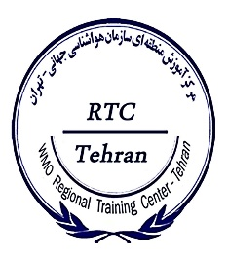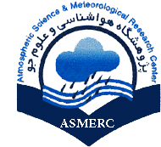

**Thermal and Microwave Remote Sensing:**

**“Application for Water Vapour, Cloud and Precipitation”**

(15-16 September 2020)

**PARTICIPANT NOMINATION FORM**

The Permanent Representative/ Hydrological Adviser of _______________________________

with WMO nominates the following candidate to participate in the above course:

**PERSONAL DETAILS**

**FAMILY NAME:**

**FIRST NAME:**

**GENDER: MALE FEMALE**

|  |  |
| --- | --- |
| **POSTAL ADDRESS:** | _______________________________________ |
|  | _______________________________________ |
|  | _______________________________________ |
| **ORGANIZATION:** | ________________________________________ |
| **E-MAIL:** | ________________________________________ |
|  |  |
| **FAX NUMBER:** | ________________________________________ |
| **TELEPHONE NUMBER:** | ________________________________________ |
| **SIGNATURE:** | ________________________________________ |

Please send nomination form to: [wmotehranrtc@gmail.com](mailto:wmotehranrtc@gmail.com)**no later than 09 September 2020**